[Insert Organization/School Name]

Preventing Tick and Mosquito bites

Prevention and tick removal
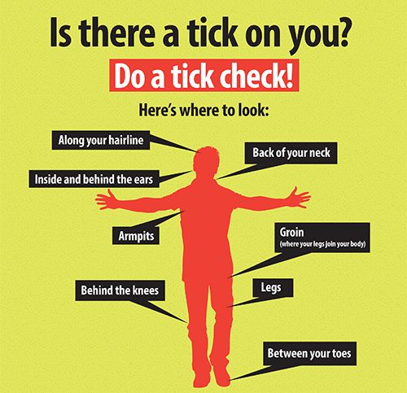
- Children will be given age-appropriate lessons about ticks and mosquitoes, tick- and mosquito-borne diseases, and methods of prevention and removal.
- Children will be encouraged to wear long sleeved shirts and pants when spending time outdoors, particularly at dawn and dusk.
- Parents are asked to provide hiking clothes, such as long pants and long socks, in their child's extra clothes bag, if applicable, as well as a separate storage bag for the hiking clothes.
- Parents are asked to spray children with insect repellent (after applying sunscreen) with between 20%-30% DEET before they drop their children off. [OPTIONAL: Parents are also asked to send in a bottle of insect repellent, labelled with the child’s name, so it can be re-applied throughout the day.]
- Children should have sneakers or boots at school at all times to be worn during hikes.
- After time spent outdoors, children will be encouraged to check each other for ticks, especially in areas behind the knees and the back of the neck. [INSERT TEACHER’S NAME/STAFF] will inform parents when the children have been in the woods or in a field area so that further checks may be done at home.
- Removal of a tick within 24-36 hours of attachment can help prevent disease transmission. If a tick is discovered unattached on a child, we will remove it promptly and discard it. If we find a tick attached to the skin, we will remove it using the CDC recommendations as follows. We will:
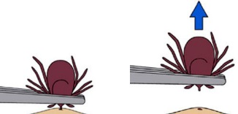
• Use a tick removal instrument to grasp the tick as close to the skins surface as possible.
• Pull upward with steady, even pressure.
• Thoroughly clean the bite area with rubbing alcohol or soap and water after removing the tick.
- If a tick is removed, the parent will be notified and [the tick will be put into a plastic bag or taped onto a card, labeled with the date, time and place, and sent home.] [OR] [the tick will be kept in the child’s file and an email or verbal notice will be sent to parents.] A log is kept of ticks found and removed. Visit the Rhode Island Department of Health’s web pages at http://health.ri.gov/ticks and http://health.ri.gov/mosquito for more information.
- [School/Organization] will empty and scrub, turn over, cover, or throw out items that hold water to stop mosquitoes from laying eggs on school property.

